a)If the Nyquist samples are uniformly quantized into L= 65,536 levels and thenbinary-coded; determine the number of binary digits (bits)nrequired to encode asample.

.

×For 15 kHz as the upper frequency of signal(), the Nyquistsampling rate = 215 kHz = 30 KHz.This means we must take30,000 samples/second.We have 65,536 levels which correspondsto 16 bits of rem t×⇐solution (We get this from 65,536 = 2^n ; so solving for n gives n= 16 bits.Thus, the transmission rate is16 bits/sample30,000 samples/ second= 480,000 bits/second

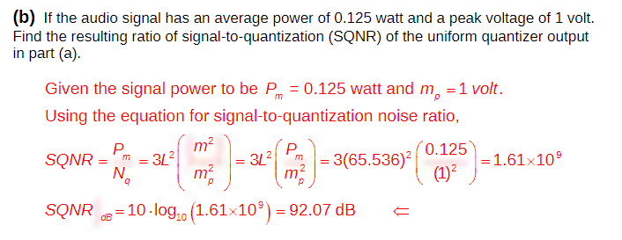

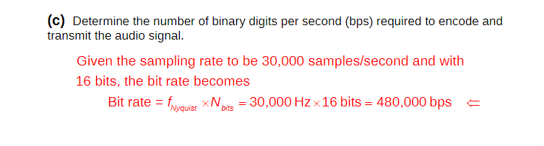

. Lathi 6.2-2: (a): the bandwidth is 15 kHz. The Nyquist rate is 30 kHz. (b): 65536 = 216, so that 16 binary digits are needed to encode each sample. (c): 30, 000 × 16 = 480, 000 bits/s. (d): 44, 100 × 16 = 705, 600 bits/s.